**INTI International College Penang School of Engineering and Technology**

**3+0 Bachelor of Science (Hons) in Computer Science, in collaboration with Coventry University, UK**

**3+0 Bachelor of Science (Hons) in Computing, in collaboration with Coventry University, UK**

**Coursework cover sheet**

**Section A - To be completed by the student**

|  |  |
| --- | --- |
| Full Name: Sulaiman Sidek Bin Azman Shah | |
| CU Student ID Number: P21013694 | |
| Semester: 3 | |
| Session:  **April 2022** | |
| Lecturer:  **Nadhrah Abdul Hadi (nadhrah.abdulhadi@newinti.edu.my)** | |
| Module Code and Title:  **4067CEM Software Design** | |
| Assignment No. / Title:  **Continuous Assessment** | % of Module Mark:  **50** |
| Hand out Date:  **22nd April 2022** | Due Date:  **Task 1: 13 May 2022, by 11.59pm**  **Task 2: 1 July 2022, by 11.59pm**  **Task 3: 17 June 2022, by 11.59pm.**  **Task 4: 17 June 2022, by 11.59pm.**  **Task 5: 17 June 2022, by 11.59pm.** |
| Penalties: No late work will be accepted. If you are unable to submit coursework on time due to extenuating circumstances, you may be eligible for an extension. Please consult the lecturer. | |
| Declaration: I/we the undersigned confirm that I/we have read and agree to abide by the University regulations on plagiarism and cheating and Faculty coursework policies and procedures. I/we confirm that this piece of work is my/our own. I/we consent to appropriate storage of our work for plagiarism checking.  Signature(s): ________________________ | |

**Section B - To be completed by the module leader**

|  |  |  |
| --- | --- | --- |
| Intended learning outcomes assessed by this work:  1. Understand and apply appropriate concepts, tools and techniques to each stage of the software development  2. Understand and apply design patterns to software components in developing new software  3. Demonstrate an understanding of project planning and working to agreed deadlines, along with professional, interpersonal skills and effective communication required for software production  5. Demonstrate an awareness of, and ability to apply, social, professional, legal and ethical standards as documented in relevant laws and professional codes of conduct such as that of the Malaysian National Computer Confederation. | | |
| Marking scheme | Max | Mark |
| 1. User Story Mapping 2. Setting up a GitHub Repository 3. Creating a Class diagram and design pattern selection 4. Creating a Prototype User Interface and Usability Testing 5. Discuss the ethical issue related to the software | 20  10  30  20  20 |  |
| Total | 100 |  |

**Prototype**

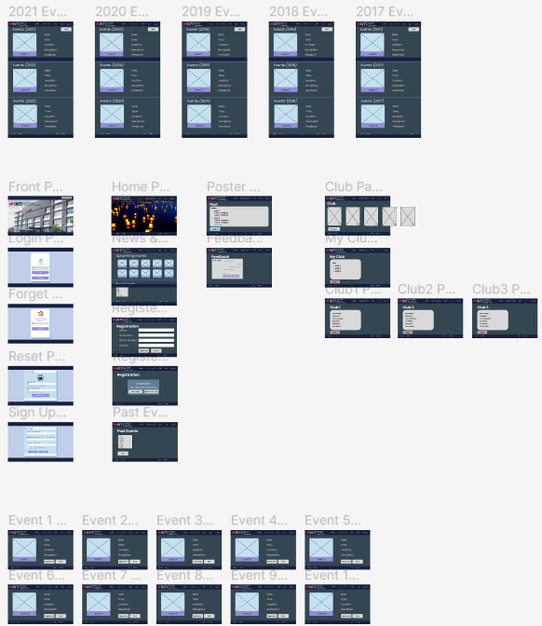

The link to the prototype is <https://www.figma.com/file/pndoqRNNLaluQmj9KR4ij4/Untitled?node-id=0%3A1>

The two important functions in this system are:

* The login system
* The registration system

**The Usability Questions**

**Question 1**

How to login to the website?



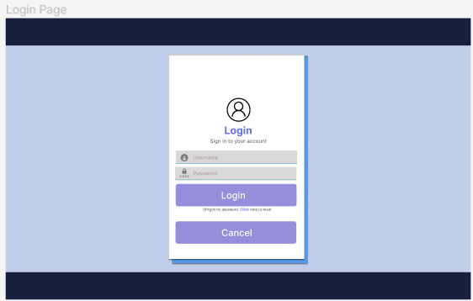

**Question 2**

How to sign up for this website?



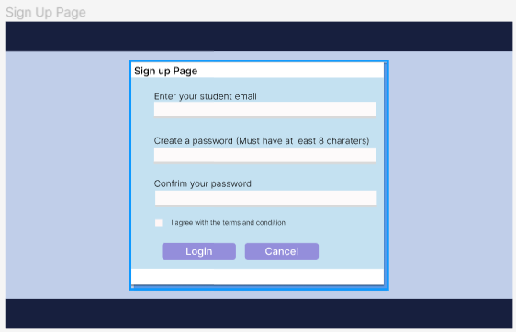

**Question 3**

How to change password, if I can’t remember my previous one?

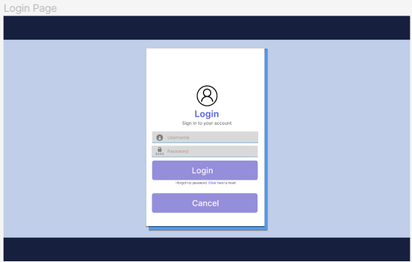

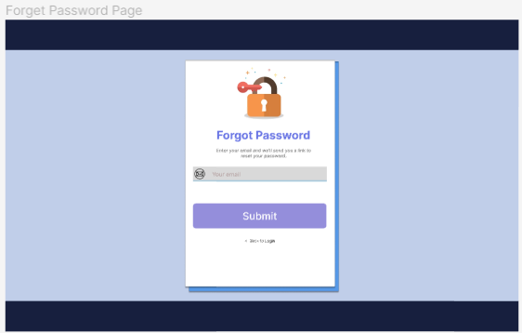

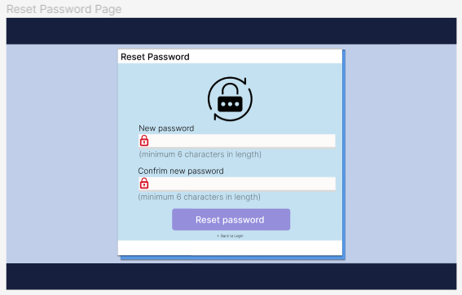

**Question 4**

How to see all the upcoming event and news?



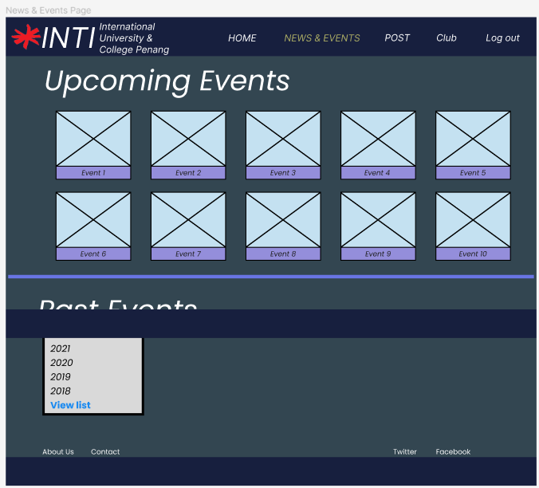

**Question 5**

How to check a current event detail?

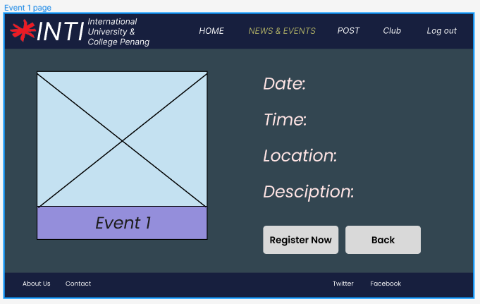

**Question 6**

How to check the past event detail?

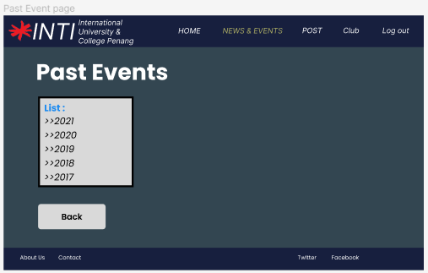

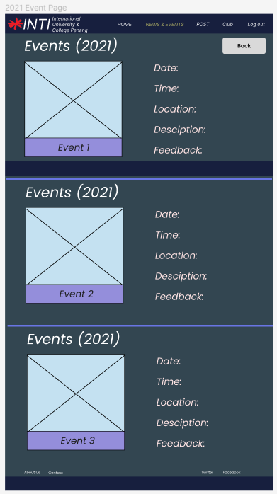

**Question 7**

How to register for an event?

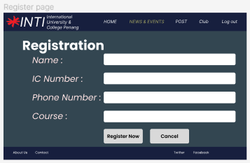

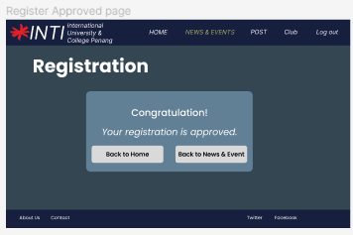

**Question 8**

Where can I view all the feedback for any event?

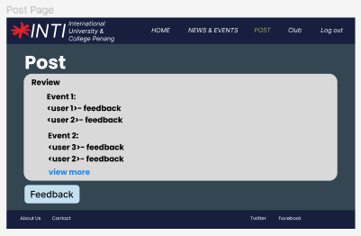

**Question 9**

Where should I post my personal feedback for any event?

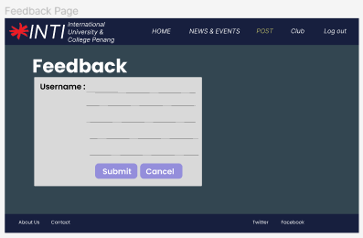

**Question 10**

Where can I view all the list of clubs in this website?

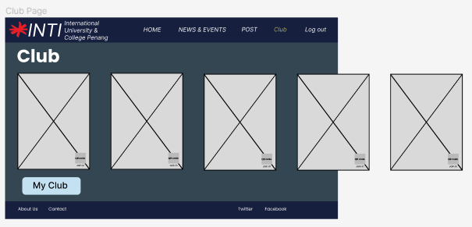

**Question 11**

How to see all my clubs that I join and view the details?

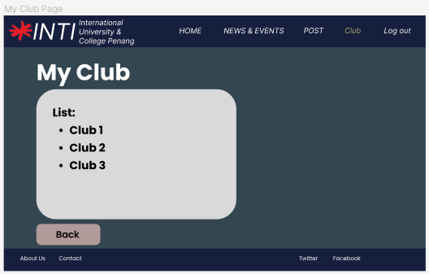

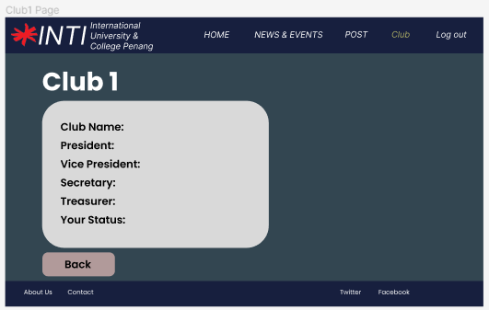

**Question 12**

How to log out from the website?



